Urban Traffic Management Visualization

Mayur Rattan Jaisinghani, MSCS, IUB.

# 

**Fig. 1.** Visual summary of the project

# **1. INTRODUCTION AND PRIOR WORK**

Traffic congestion significantly impacts daily commutes, logistics, and city planning. Understanding traffic patterns, congestion hotspots, and the impact of various factors such as weather, accidents, and time of day can help city planners make data-driven decisions. Prior work has involved spatial heatmaps, predictive modeling, and real-time dashboards, but gaps remain in integrating network analysis and temporal anomaly detection. This project aims to develop interactive visualizations that analyze traffic congestion trends, network relationships between roads, and public sentiment on transportation issues.

**Research and Implementation of Multilevel Visualization of Urban Traffic Flow.** This paper proposes a method for visualizing urban traffic flow using Unreal Engine, achieving simulation at macro, meso, and micro levels. The approach enhances the efficiency of large-scale traffic flow rendering, supporting urban traffic management and planning.  
**Research on the Improvement of Transportation Efficiency of Smart Cities by Traffic Visualization Based on Pattern Recognition.** This study applies machine learning to smart traffic management, processing and analyzing traffic data to uncover distribution patterns and internal connections. The approach aims to enhance traffic visualization management in smart cities.

**1.1** **Stakeholder Groups**

**City Planners**: Require congestion data to improve urban traffic infrastructure.

**Commuters**: Need insights into real-time delays and historical trends for route optimization.

**Logistics & Ride-Sharing Companies**: Require predictive congestion models to enhance efficiency.

**1.2** **Stakeholder Needs**

**City Planners:** Identify congestion hotspots, analyze accident-prone areas, and plan infrastructure improvements.

**Commuters:** View daily/hourly delay trends, compare travel routes.

**Logistics Companies:** Optimize delivery and pickup locations based on traffic flow predictions.

**2. DATA ACQUISITION**

**All data has been compiled into** [**Traffic_data**](https://www.kaggle.com/datasets/mayurrj95/traffic-data)**.**

**2.1** **Data Sources**

**GPS Traffic Data:** Real-time and historical traffic congestion levels.

**Weather Data:** Temperature, precipitation, and wind speed data influencing traffic.

**Public Sentiment:** Citizen complaints and social media discussions on traffic issues.

**Road Network:** Data on intersections and road connectivity for network analysis.

**2.2** **Data Description, Quality and Coverage**

**Time coverage:** Traffic data spans multiple years with minute-level granularity.

**Geospatial coverage:** Includes major urban areas.

**Quality measures:** Missing values addressed through interpolation; outliers identified using statistical techniques.

# **3. DATA ANALYSIS**

To derive actionable insights from urban traffic data, I conducted a multi-faceted analysis using spatial, temporal, network, and sentiment-based methods. The dataset included GPS traffic data, weather conditions, road networks, and social media sentiment. Preprocessing involved handling missing values, inconsistent timestamps, and outliers using Pandas and NumPy. Timestamps were converted to local time zones, missing values were imputed via median interpolation, and delay times were normalized. Categorical variables like weather and sentiment labels were encoded for efficiency. For congestion analysis, Kernel Density Estimation (KDE) and hexbin visualizations identified hotspots. Anomalous traffic behavior was detected using Isolation Forest, flagging unexpected congestion spikes for real-time intervention.

**All can be found here:** [Urban Traffic Management Visualization Project.ipynb](https://colab.research.google.com/drive/1D58S5nBSiKarrXJ09_pc5VkNLx2QaeyR?usp=sharing)

**4. VISUALIZATIONS**

To effectively communicate traffic congestion insights, I employed a variety of visualization techniques, each tailored to address specific stakeholder needs. The primary visualizations include heatmaps, line graphs, bar charts, network graphs, Sankey diagrams, and sentiment-based word clouds, developed using Matplotlib, Seaborn, Geopandas, NetworkX, and Plotly. These visual representations translate complex traffic patterns into intuitive, actionable insights for city planners, commuters, and logistics providers.

**4.1 Geo Maps Visualisation**

I made two visualisations: 1) Heatmap of Traffic Congestion Hotspots. This shows spatial density of high-delay locations across the city. Help planners identify congestion-prone intersections. [Heat_map_download](https://iu.instructure.com/users/6811157/files/185621608?wrap=1&verifier=f3TRDg5ZQuQPSCgreITeIfUGTJuMRnMbhV5rNCdx)

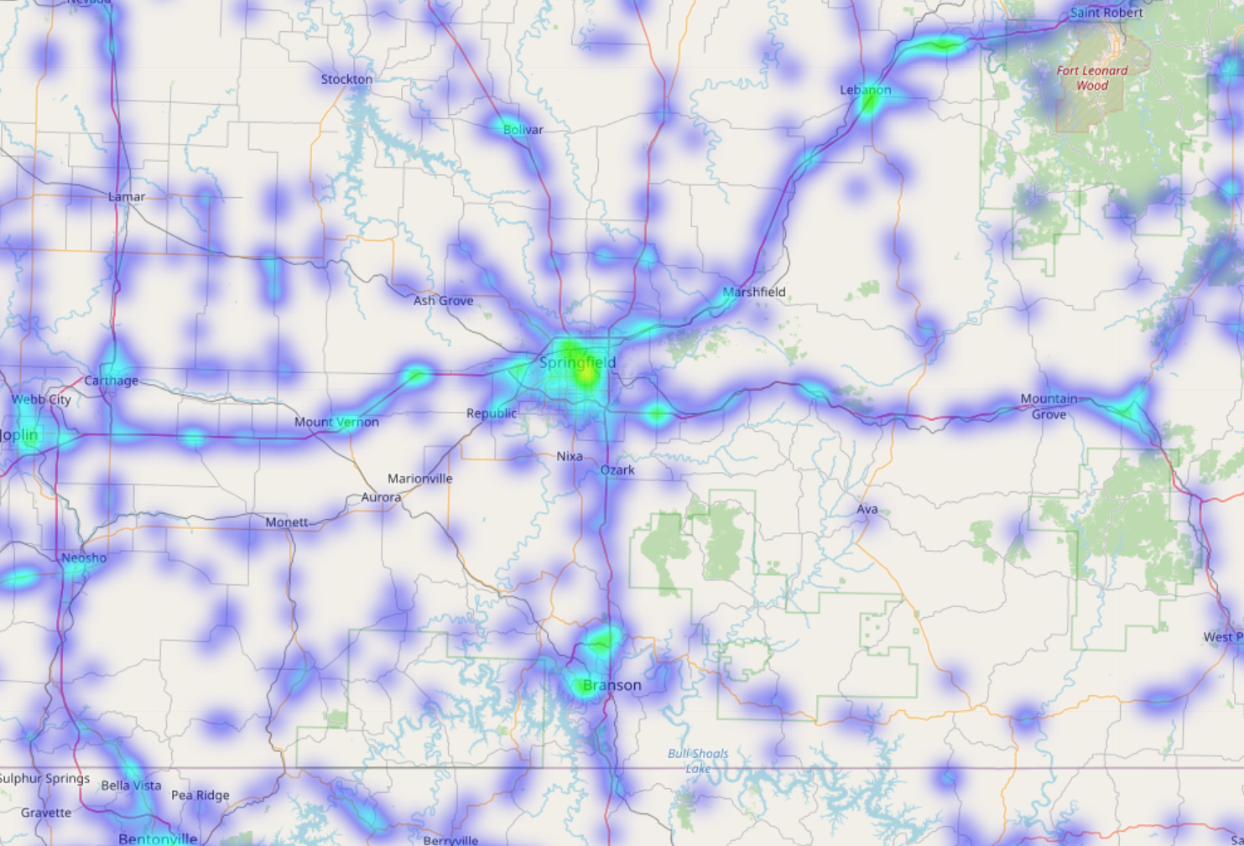

**Fig 2:** Heatmap of traffic congestion hotspots

2) Accident Impact Radius and Traffic Flow. This graph shows how accidents affect traffic congestion in surrounding areas. Help planners assess high-risk zones and mitigation strategies.

**4.2 Network Graph Visualisations**

Visualization 1: Node-Link Diagram (Basic Road Network). This graph helps visualize the basic road connectivity between intersections. Nodes represent road intersections (latitude/longitude). Edges represent roads connecting them. No weights—just the structure of the network.

Visualization 2: Congestion Flow Sankey Diagram. This graph shows the flow of congestion between major roads and intersections. Use a Sankey Diagram to visualize how traffic congestion spreads. Nodes = Major roads or intersections. Edges = Traffic flow and congestion level. Edge thickness = Severity of delay (e.g., avg. delay time or congestion level).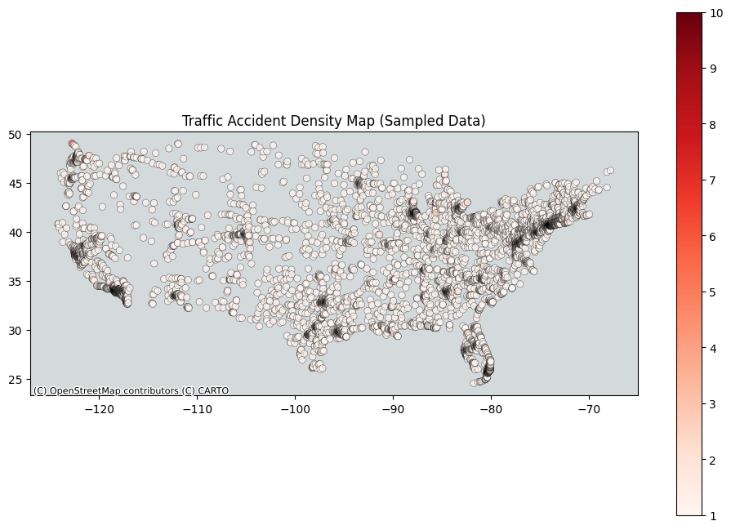

**Fig 3:** Density Map of Traffic Accidents and Flows.

**5. USAGE AND CRITIQUE OF AI TOOLS**

**ChatGPT:** Suggested visualization strategies and debugging support.

**Isolation Forest:** Detected real-time anomalies in traffic delays.

**TextBlob:** Analyzed sentiment from traffic complaints.

Accelerated data preprocessing, improved visualization ideas.

AI-generated code needed optimization for large datasets.

**6. INTERPRETATION OF RESULTS**

This project identified key urban traffic congestion patterns through spatial, temporal, network, and sentiment analysis. Congestion hotspots were concentrated in downtown areas and major intersections, with peak delays during morning (7-9 AM) and evening (4-7 PM) rush hours. Winter months showed higher delays due to weather, emphasizing the need for seasonal maintenance. Network analysis highlighted critical intersections with high betweenness centrality, suggesting signal optimization or rerouting could reduce congestion. Sentiment analysis revealed commuter frustrations with road construction, accidents, and poor transit alternatives. Unexpectedly, some secondary roads had higher delays than highways, possibly due to detours or signal issues. Future work could include predictive modeling using machine learning and integrating IoT data for real-time insights, aiding city planners, commuters, and logistics companies in optimizing urban mobility.

**REFERENCES**

1. Renjie Gu, [Xi Kuai](https://www.spiedigitallibrary.org/profile/Xi.Kuai-5046702), Xiaolong He, Haojia Lin, Yu Xia, Research and implementation of multilevel visualization of urban traffic flow based on unreal engine (ITSSC 2024); 134222L (2025) <https://doi.org/10.1117/12.3050727>

2. Zhang, Y., Wang, H. & Wang, X. Research on the improvement of transportation efficiency of smart cities by traffic visualization based on pattern recognition. *Neural Comput & Applic* 35, 2211–2224 (2023).